

A major project report on

**GAS & SMOKE DETECTION SYSTEM**

**And PREVENTION SYSTEM WITH GSM SMS ALERT**

Submitted by

ASHISH KUMAR ROY(1807258)

ASHUTOSH YADAV(1807259)

B DHEERAJ CHANDAN(1807265)

BISWAYAN BANERJEE(1807266)

PRIYA SAI MANOHAR (1807292)

Under the guidance of:

**Prof. Rishi Kumar Khanna**

**B.Tech. in Electronics and Electrical Engineering**

**School of Electronics Engineering**

**Kalinga Institute of Industrial Technology, Deemed to be University**

**Bhubaneswar, India**

**March 2022**

**CERTIFICATE**

This is to certify that the project report entitled

**OBSTACLE DETECTOR USING ULTRA SONIC SENSOR**

submitted by

|  |  |  |
| --- | --- | --- |
| ASHISH KUMAR ROY | **1807258** |  |
| ASHUTOSH YADAV | **1807259** |  |
| B DHEERAJ CHANDAN | **1807265** | image |
| BISWAYAN BANERJEE | **1807266** | 1610372883768 |
| PRIYA SAI MANOHAR | **1807292** |  |

In partial fulfillment of the requirements for the award of the **Degree of Bachelor of Technology in Electronics and Electrical Engineering** is a bonafide record of the work carried out under my(our) guidance and supervision at the School of Electronics Engineering, KIIT University.

Signature of Supervisor

Prof. Rishi Kumar Khanna

School of ElectronicsEngineering

KIIT DEEMED to beUNIVERSITY

**Acknowledgment**

We feel immense pleasure and feel privileged in expressing our deepest and most sincere gratitude to our supervisor **Prof. Rishi Kumar Khanna** for his excellent guidance throughout our project work. His kindness, dedication, hard work and attention to detail have been a great inspiration to us. Our heartfelt thanks to you Sir for the unlimited support and patience shown to us. We would particularly like to thank him for all his help in patiently and carefully correcting all our manuscripts.

We are also very thankful to and **prof.P.Biswal,** **Prof.M.Ramana** and **Prof.Suman Roy** our B.tech project coordinators (E&E), associate Dean **Prof.(Dr.) Amlan Datta** and **Prof. (Dr.) Suprava patnaik** Dean (School Of Electronics) for their support and suggestions during our course of the project work in the pre-final year of our undergraduate course.

|  |  |  |
| --- | --- | --- |
| ASHISH KUMAR ROY | **1807258** |  |
| ASHUTOSH YADAV | **1807259** |  |
| B DHEERAJ CHANDAN | **1807265** | image |
| BISWAYAN BANERJEE | **1807266** | 1610372883768 |
| PRIYA SAI MANOHAR | **1807292** |  |

**ABSTRACT**

Main outlook of the project is to demonstrate the gas and smoke leak detection technique of an Arduino based system.

Nowadays, securing one's property and business against fire is becoming more and more important.

Monitoring commercial and residential areas all-round is an effective method to reduce personal and property losses due to fire disaster.

Home fire detection is a matter of great concern, and thus many efforts are devoted in most developed countries to the design of automatic detection systems, A alarm system should reliably and in a

timely way notify building occupants about the presence of fire indicators, such as smoke or high

temperatures. A fire detector is usually implemented as a smoke sensor due to its early fire detection capability, fast response time and relatively low cost. Other options for the fire detection are based on gas sensors

**TABLE OF CONTENTS**

|  |
| --- |
| Chapter 1: INTRODUCTION |
| * 1. Objective of project |
|  |

Chapter 2 : PROJECT COMPONENTS

2.1 Hardware Components

|  |  |
| --- | --- |
| 2.1.1 Arduino UNO R3  2.1.1(A) Technical Specifications    2.1.1(B) General Pin Functions  2.1.1(C) Communication   |  | | --- | | 2.1.2 MQ-2 Gas Sensor    2.1.3 16X2 LCD Display    2.1.4 MQ-3 Smoke Sensor    2.1.5 SIM 900D GSM MODULE |   2.1.6 JUMPER WIRES |
| 2.1.7 Dc Motor  2.1.8 Servo motor    2.1.9 RESISTOR    2.2.0 Buzzer |
|  |

2.2 Software Used

2.2.1 Arduino IDE 1.8

2.2.2 Proteus Design suite

Chapter 3: PROJECT ANALYSIS

|  |
| --- |
| 3.1 Circuit Diagram |
| 3.2 Project Description |

3.3 Working

3.4 code

|  |
| --- |
| Chapter 4 : CONCLUSION AND SCOPE OF FURTHER WORK |
| 4.1 Summary    4.2 Future scope |
| 4.3 Weight Budget Analysis |
| 4.4 Cost Analysis |
| Chapter 5: PLANNING AND PROJECT MANAGEMENT  Chapter 6: REFERENCES |
|  |

**CHAPTER 2**

**PROJECT COMPONENTS**

**2.1 HARDWARE COMPONENTS**

**2.1.1 ARDUINO ATMEGA328P**

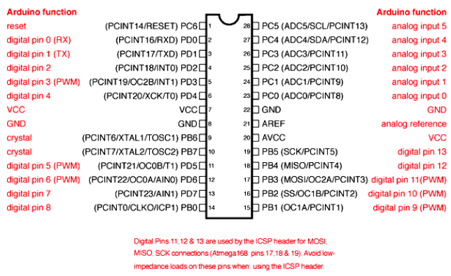

.

The Arduino Atmega 328 is a micro controller board based on dual-inline-package (DIP) ATmega328 AVR micro controller.

ATmega328P is a high performance yet low power consumption 8-bit AVR micro controller

It can commonly be found as a processor in Arduino boards such as a Arduino Uno.

The boards feature serial communications interfaces, including USB on some models, for

loading programs from personal computers. For programming the micro controllers, the

Arduino project provides an *integrated development environment (IDE)* based on

the Processing project, which includes support for the *C* and *C++* programming

languages.

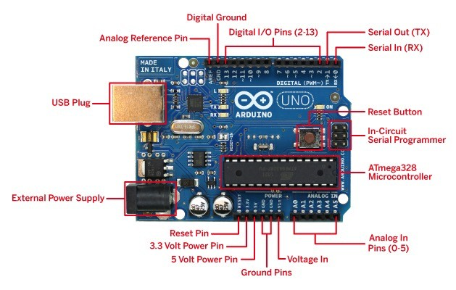

Fig 2.1 ARDUINO UNO R3

**2.1.1(a) TECHNICAL SPECIFICATIONS**

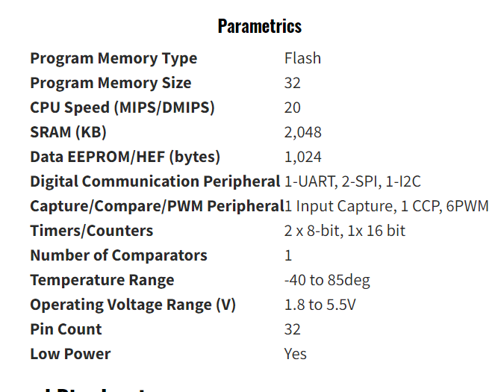

**2.1.1(b) GENERAL PIN FUNCTIONS**

|  |  |  |
| --- | --- | --- |
| **Pin Category** | **Pin Name** | **Details** |
| Power | Reset | Vin: Input voltage to Arduino  5V: Regulated power supply  3.3V: 3.3V supply  GND: ground pins. |
| Reset | A0 – A5 | Resets the micro controller. |
| Analog Pins | Digital Pins 0 - 13 | provide analog input in the range of 0-5V |
| Input/Output Pins | 0(Rx), 1(Tx) | used as input or output pins. |
| Serial | 2, 3 | receive and transmit TTL serial data. |
| External Interrupts | 3, 5, 6, 9, 11 | trigger an interrupt. |
| PWM | 10 (SS), 11 (MOSI), 12 (MISO) and 13 (SCK) | Provides 8-bit PWM output. |
| SPI | 13 | SPI communication. |
| Inbuilt LED | A4 (SDA), A5 (SCA) | To turn on the inbuilt LED. |
| TWI | AREF | TWI communication. |
| AREF | AREF | providing reference voltage for input voltage. |

**2.1.2MQ-2 GAS SENSOR**

MQ2 is one of the commonly used gas sensors in MQ sensor series.

It is a Metal Oxide Semiconductor (MOS) type Gas Sensor also known as Chemiresistors as the detection is based upon change of resistance of the sensing material when the Gas comes in contact with the material. Using a simple voltage divider network, concentrations of gas can be detected.

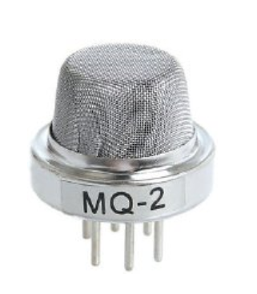

**2.1.3 16X2 LCD DISPLAY**

A liquid crystal display or LCD draws its definition from its name itself. It is combination

of two states of matter, the solid and the liquid. LCD uses a liquid crystal to produce a visible image. 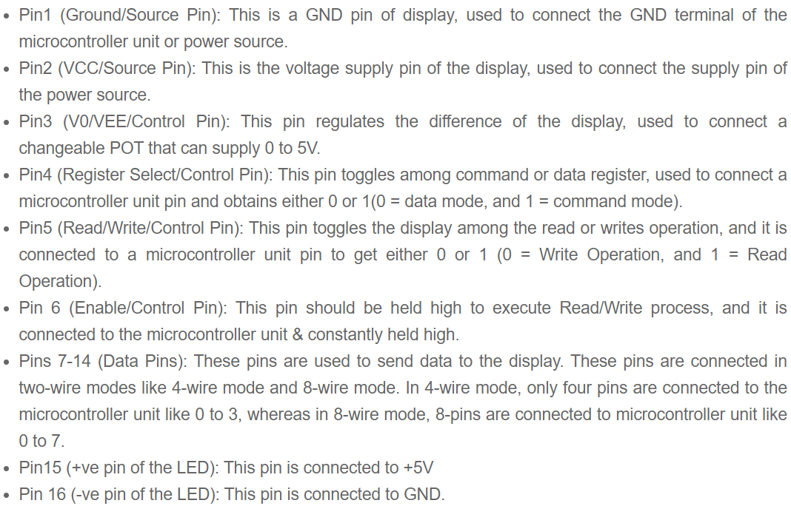

**16×2 LCD** is named so because; it has 16 Columns and 2 Rows. There are a lot of combinations available like, 8×1, 8×2, 10×2, 16×1, etc. but the most used one is the 16×2 LCD. So, it will have (16×2=32) 32 characters in total and each character will be made of 5×8 Pixel Dots.

### ****Features of 16×2 LCD module****

* Operating Voltage is 4.7V
* Current -1mA
* Alphanumeric LCD display module,
* character is build by a 5×8 pixel box
* Can work on both 8-bit and 4-bit mode

|  |  |  |
| --- | --- | --- |
| **Pin No:** | **Pin Name:** | **Description** |
| 1 | Vss | Supply pin |
| 2 | Vdd (+5 ) | Powers the LCD with +5V (4.7V – 5.3V) |
| 3 | VE | Controls contrast level of display. |
| 4 | Register Select | Connects to Micro controller to shift between command |
| 5 | Read/Write | read or write data. |
| 6 | Enable | Connects to Micro controller Pin and toggled between 1 and 0 for data |
| 7 | Data Pin 0 | Data pins 0 to 7 forms a 8-bit data line.  These LCD’s can also operate on 4-bit mode in such case Data pin 4,5,6 and 7 will be left free. |
| 8 | Data Pin 1 |  |
| 9 | Data Pin 2 |  |
| 10 | Data Pin 3 |  |
| 11 | Data Pin 4 |  |
| 12 | Data Pin 5 |  |
| 13 | Data Pin 6 |  |
| 14 | Data Pin 7 |  |
| 15 | LED Positive | LED pin positive terminal |
| 16 | LED Negative | LED pin negative terminal |

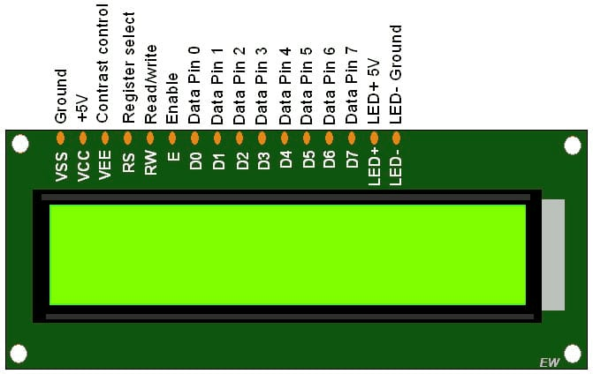

**2.1.5 MQ-3 SMOKE SENSOR**

MQ-3 sensor module is usefull module for detecting alcohol or smoke concentration.

Operating voltage: 5V DC Features:Microprocessor compatible TTL output.

High sensitivity.It measures the alcohol concentration precisely.

It can also measure smoke and alcohol with low sensitivity.

Measurement Range: 0.04-4mg / It has a long working life and stability.

Fast response time.Plug and play convenience for testing with plugged probes.

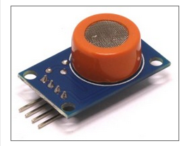

**2.1.7 SIM 900D GSM MODULE**

A customised Global System for Mobile communication (GSM) module is designed for wireless radiation monitoring through Short Messaging Service (SMS). This module is able to receive serial data from radiation monitoring devices such as survey meter or area monitor and transmit the data as text SMS to a host server.

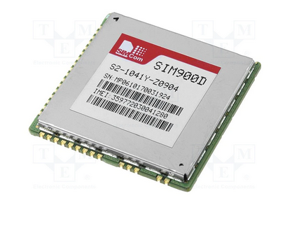 .

**2.1.9 DC MOTOR**

A simple DC motor uses a stationary set of magnets in the stator, and a coil of wire with a current running through it to generate an electromagnetic field aligned with the centre of the coil. One or more windings of insulated wire are wrapped around the core of the motor to concentrate

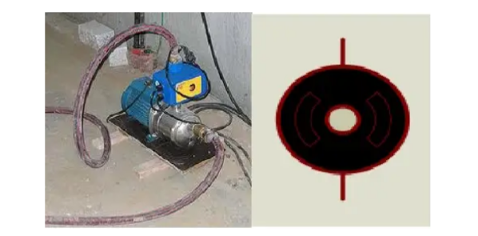

**2.2.2 DC SERVO MOTOR**

The DC servo motor definition is, a motor that is used in servo systems is known as a servo motor. A servo system is a closed-loop system

where the feedback signal (position, velocity, acceleration, etc.) drives

the motor. This signal acts as an error and based on controller, accurate position or velocity is achieved.Servo motor works on PWM (Pulse width modulation) principle, means its angle of rotation is controlled by the duration of applied pulse to its Control PIN. Basically servo motor is made up of DC motor which is controlled by a variable resistor (potentiometer) and some gears.

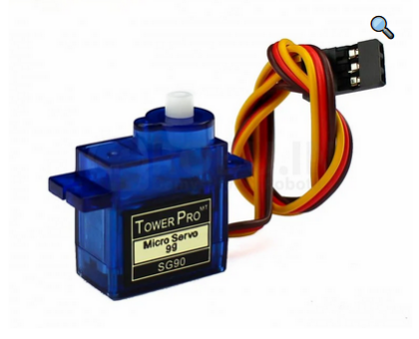

**2.2 SOFT WARE USED**

**2.2.1 ARDUINO IDE**

The Arduino (IDE) is such an application that may be deployed across several platforms like Windows, mac OS and UNIX operating system, Java being the artificial language. It is used to write and transfer programs to Arduino compatible boards. However with the help of third party cores, it also can be used to transfer codes to alternative merchant development boards.

The languages supported by the Arduino IDE square measure primarily C and C++ , additionally to that special rules of code structuring square measure used, as could also be compatible.User-written code includes 2 basic functions, one for beginning the sketch and also the alternative one being the most program loop, that square measure compiled and joined with a program stub main() into an feasible cyclic computer programme with the help of wildebeest tool-chain, that's enclosed with the IDE distribution.The Arduino IDE uses the program avrdude to perform the conversion of feasible code into a document in hex that's finally loaded into the Arduino board , that a loader program within the board's code is used.

**2.2.2 PROTEUS DESIGN SUITE**

The **Proteus Design Suite** is a software tool used primarily for [electronic design automation](https://en.wikipedia.org/wiki/Electronic_design_automation" \o "Electronic design automation). The software is used mainly by electronic [design engineers](https://en.wikipedia.org/wiki/Design_engineer" \o "Design engineer) and technicians to create designs and electronic prints for manufacturing [printed circuit boards](https://en.wikipedia.org/wiki/Printed_circuit_board" \o "Printed circuit board).

**CHAPTER 3**

**PROJECT ANALYSIS**

**3.1 CIRCUIT DIAGRAM**

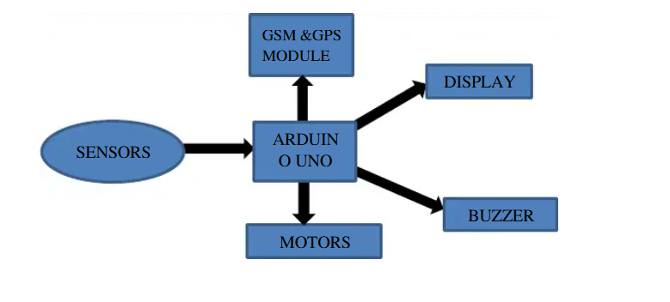

**Fig 3.6 : Circuit Connection**

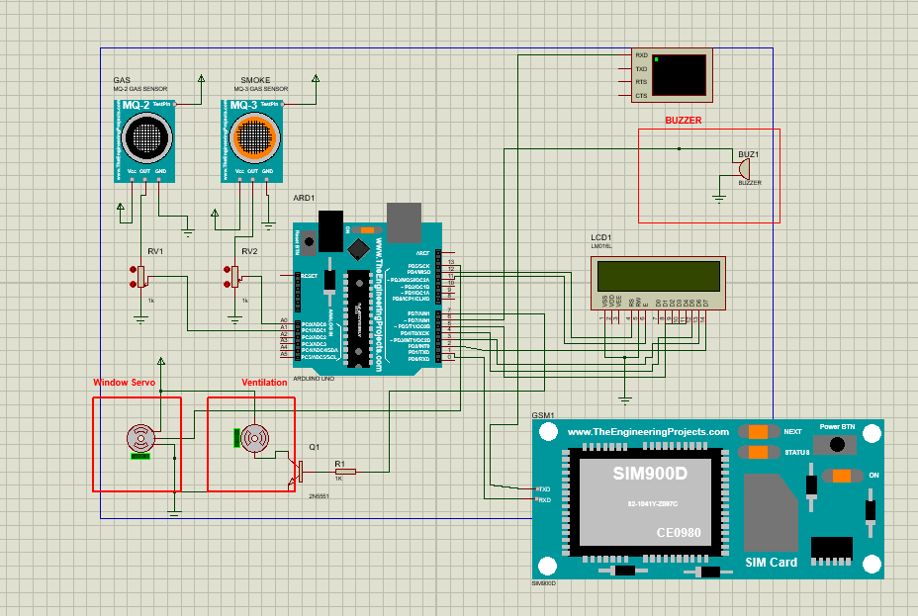

**3.3 WORKING**

In the project the main role goes to smoke sensor and gas sensor

first we connect all the main components like gas sensor and smoke sensor to arduino.

1.GAS SENSOR

we initialize sensor value to zeroand we assume if the value is above 50 then the gas is detected

It is a Metal Oxide Semiconductor (MOS) type Gas Sensor as the detection is based upon change of resistance of the sensing material when the Gas

comes in contact with the material. Using a simple voltage divider network, concentrations of gas can be detected.MQ2 Gas sensor works on 5V DC and draws around 800mW. It can detect LPG, Smoke, Alcohol, Propane, Hydrogen, Methane and Carbon Monoxide.

2.SMOKE SENSOR

If you're using a 5V Arduino, and connecting the sensor directly into an Analog pin, you can use these formulas to turn the 10-bit analog reading into a

temperature:

Voltage at pin in milliVolts = (reading from ADC) * (5000/1024)

This formula converts the number 0-1023 from the ADC into 0-5000mV (= 5V)

Then, to convert millivolts into temperature, use this formula:

Centigrade temperature = [(analog voltage in mV) - 500] / 10

we initialize sensor value to zero and we assume if the value is equal or above 100 then the smoke is detected

Now we come to SIM900D GSM

To send an SMS, we should set our GSM module to Text mode first.

This is achieved by sending an AT Command “AT+CMGF=1”

After setting the GSM module to Text mode, we should the the mobile number to which we shall send the SMS. This is achieved with AT command

“AT+CMGS=”+91xxxxxxxxxx”” – where you may replace all x with the mobile

number.

The end of SMS content is identified with CTRL+Z symbol. The ASCII value of this CTRL+Z is 26. So we send a char(26) to GSM module using the line mySerial.println((char)26);

**3.4 CODE**

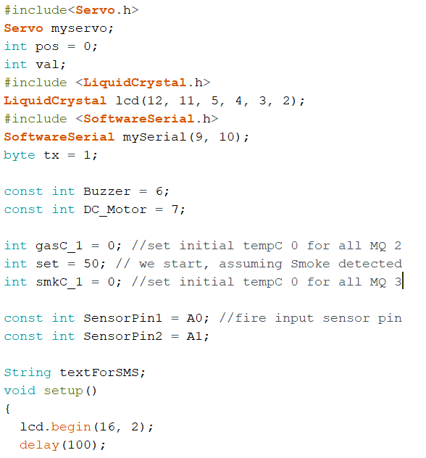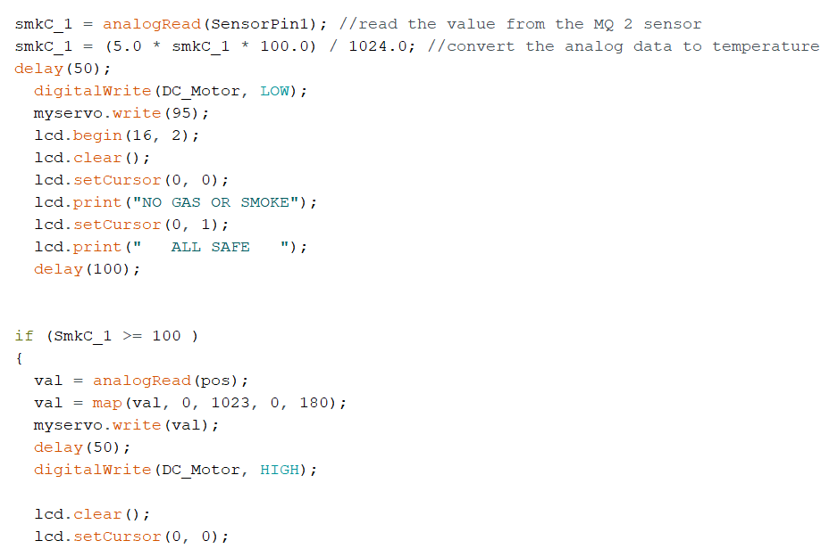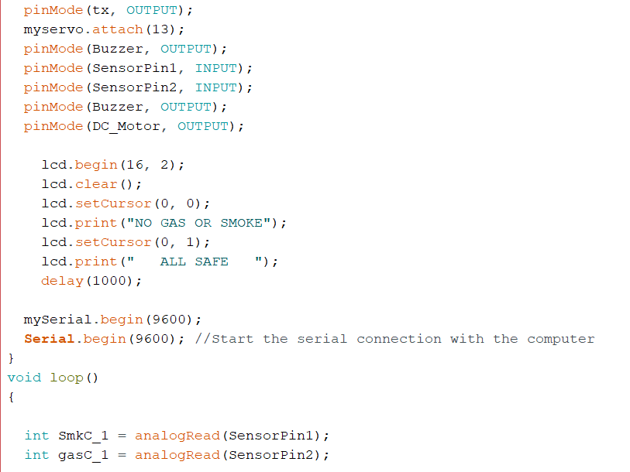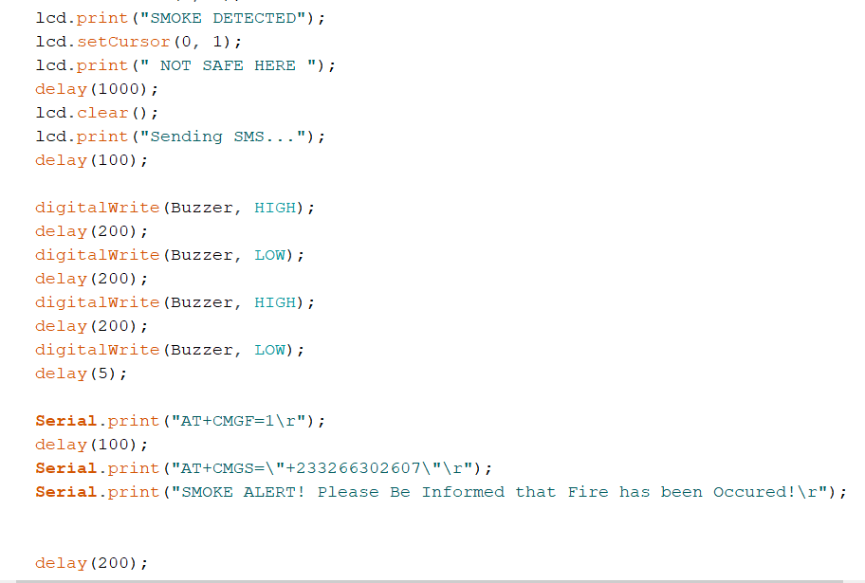

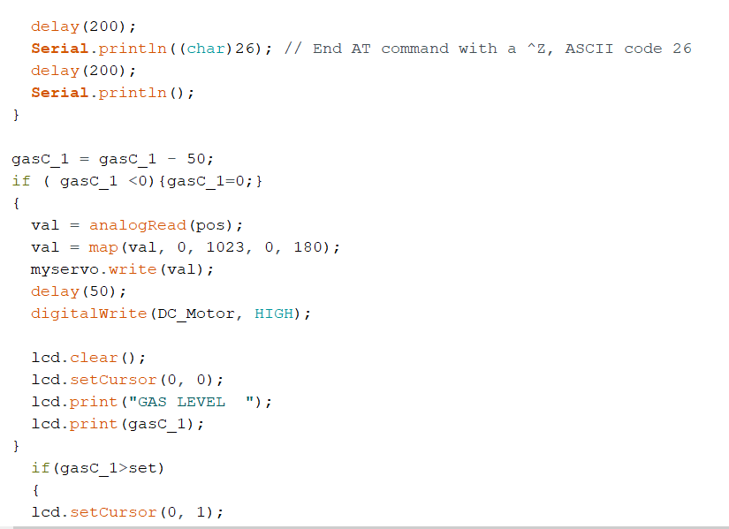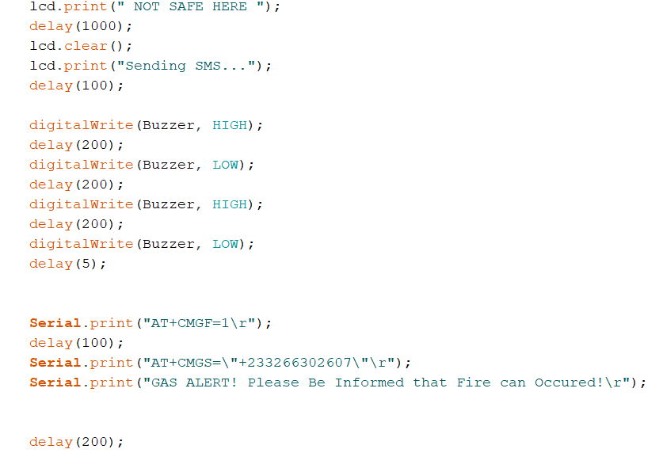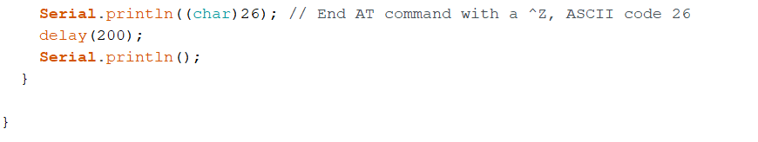

**CHAPTER 5**

**CONCLUSION AND SCOPE OF FUTURE WORK**

**5.1 SUMMARY**

**5.2 FUTURE SCOPECHAPTER 6**

**PLANNING AND PROJECT MANAGEMENT**

|  |  |  |  |
| --- | --- | --- | --- |
| **S.No.** | **activity** | **Starting Week** | **Number of Weeks** |
| 1. | Literature Review | 1st - 2nd week of august | 2 |
| 2. | Project Finalization | 3rd week of august | 1 |
| 3. | Permission for required software | 4th week of  august | 1 |
| 4. | Gathering of Hardware & Formation of codes | 3rd week of september | 1 |
| 5. | Hardware assembly calibration | 2nd week of october | 1 |
| 6. | Code Integration &  Inclusion of arduino module | 3rd week of october | 1 |
| 7. | Testing/Modification of Working model | 4th week of  october | 1 |
| 8. | Preparation of project report | 1st week of  november | 1 |
| 9. | Preparation of Project presentation | 2nd week of november | 1 |

**The Gantt Chart is shown below -**

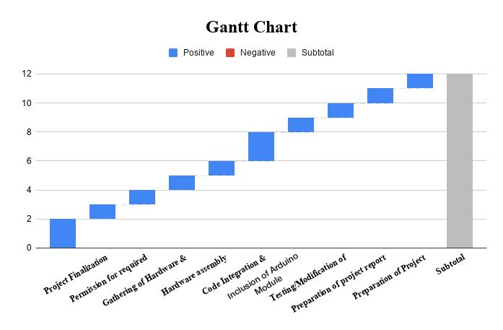

**Reference Links**

**<https://www.youtube.com/watch?v=Npydi0-4qiY>**

**<https://www.hackster.io/Jaymish1011/wire-fault-detector-a2a0ef>**

**<https://www.slideshare.net/LakhaniMansukhbhai/detection-of-fault-location-in-underground-cable-using-arduino>**

**SELF DECLARATION FOR PLAGIARISM CHECK**

We, ASHISH KUMAR ROY(1807258**),**ASHUTOSH YADAV(1807259**),**B DHEERAJ CHANDAN(1807265**),**BISWAYAN BANERJEE(1807266**),**PRIYA SAI MANOHAR(1807292**)**are declaring that our Project report on “

” has plagiarism well within the limits prescribed to us. We take the full responsibility of it.